# Six kinds of model

1. **KNN, Twitter Sentiment, GovSentiment**

**Image：**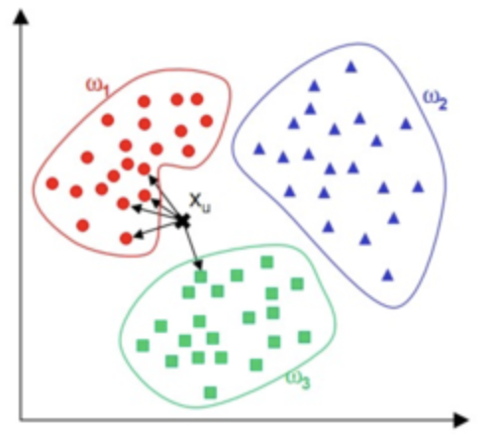

**Full name:** k-NearestNeighbor model apply to the gov sentiment analysis

**Reference api:** **sklearn.neighbors.KNeighborsClassifier**

**Principle**: If the majority of the k-most nearest samples in a feature space belong to a certain category, then this sample also belongs to this category and has the characteristics of the samples on this category.

**2.Linear, Twitter Sentiment, GovSentiment**

**Image：**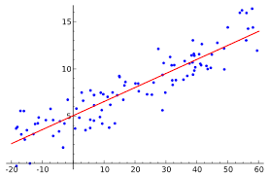

**Full name: Linear Regression model apply to the gov sentiment analysis**

**Reference API: sklearn.linear_model.LinearRegression**

**Principle**: Regard the sentiment is Linear separable and emotions corresponding to values expressed by linear regression parameters.

**3.SVM, Twitter Sentiment, GovSentiment**

**Image：**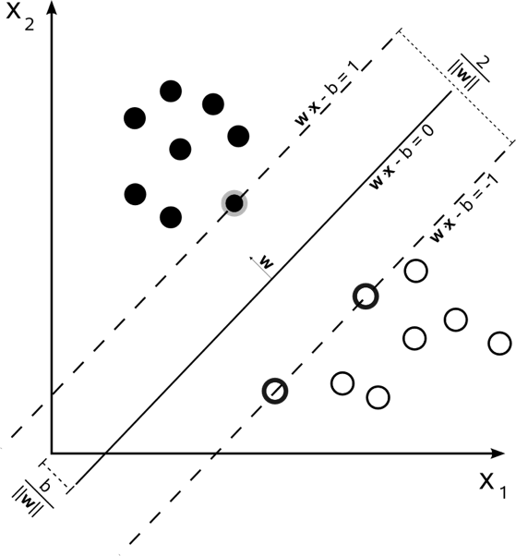

**Full name: Support victor machine apply to the gov sentiment analysis**

**Reference API: from sklearn.svm import SVR**

**Principle**: Use the hyperplane under high dimension to classify the different kinds of sentiment.

**4.LSTM30, LSTM60, LSTM90**

**Image：**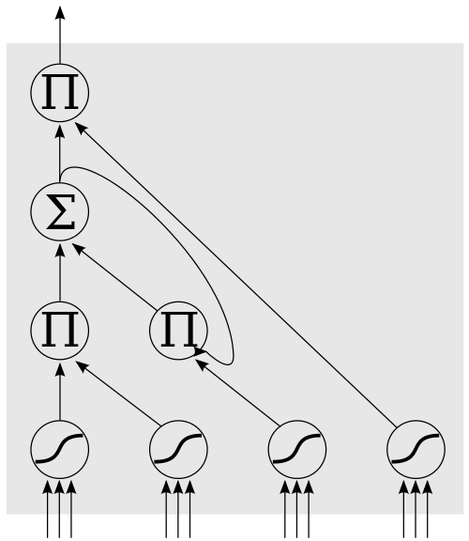

**Full name:** Long Short-Term Memory model applyed to the gov sentiment analysis

**Reference API: from keras.models import Sequential**

**from keras.layers import Dense, LSTM**

**Principle**: an artificial recurrent neural network and keep track of arbitrary long-term dependencies in the input sequences

**5.ARIMA**

**Image：**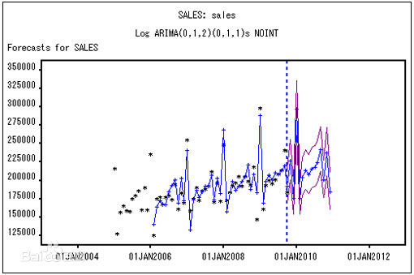

**Full name:** Autoregressive Integrated Moving Average model

apply to the gov sentiment analysis

**Reference API:** from pyramid.arima import auto_arima

**Principle**: 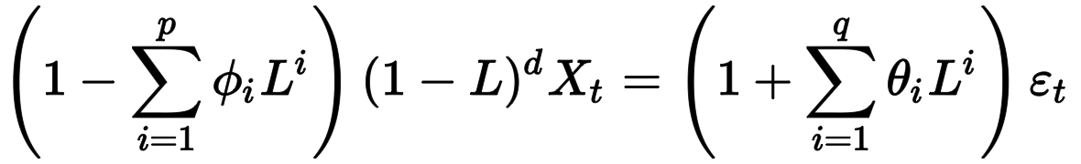 Combine autoregressive models, moving average models, and difference methods

* **AR**: Autoregression. A model that uses the dependent relationship between an observation and some number of lagged observations.
* **I**: Integrated. The use of differencing of raw observations (e.g. subtracting an observation from an observation at the previous time step) in order to make the time series stationary.
* **MA**: Moving Average. A model that uses the dependency between an observation and a residual error from a moving average model applied to lagged observations.

**6.MovingAverage**

**Image：**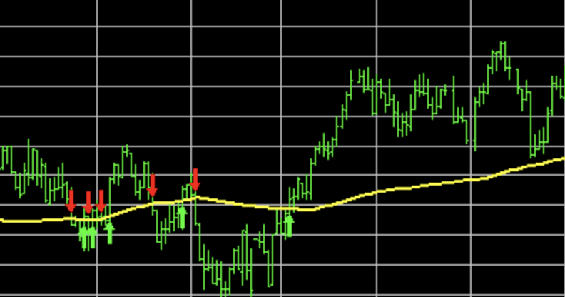

**Full name:** Moving average model apply to the gov sentiment analysis

**Reference API:** numpy ,threading together with math fomula

**Principle**: Creating a series of averages of different subsets of the full data set to analysis data point.